The Travel Shock

Gian Maria Milesi Ferretti

Hutchins Center

The Brookings Institution

First draft: July 30, 2021

This draft: August 3, 2021

Abstract

The COVID-19 pandemic has led to a collapse in international travel and tourism. This paper explores how the cross-country impact of the pandemic relates to countries’ dependence on these activities as a source of revenue. It first documents the size of the shock to net revenues from international travel and tourism for the balance of payments, which for the median highly tourism-dependent economy exceeded 10 percentage points of GDP, leading to a sizable current account deterioration. Indeed, empirical evidence suggests that current account adjustment in 2020 relative to pre-crisis forecasts was driven to an important extent by the collapse in revenues and expenditures on international travel as well as by the collapse in oil prices. On the economic growth front, the paper shows that the share of tourism activities in GDP is the single most important predictor of the growth shortfall in 2020 triggered by the COVID-19 crisis, even when compared to a variety of measures of the severity of the pandemic.

* I am greatly indebted to participants at a seminar at the Brookings Institution for very useful suggestions, and to the World Economic Outlook team at the International Monetary Fund for their help with the data. Jimena Ruiz Castro and Manuel Alcala Kovalski provided excellent research assistance.

# I. Introduction

The COVID crisis has led to a collapse in international travel, as countries imposed limits on international travel and individuals adopted social distancing measures. According to the World Tourism Organization (UNWTO, 2021a) international tourist arrivals declined globally by 73 percent in 2020, with 1 billion fewer travelers compared to 2019, putting in jeopardy between 100 and 120 million direct tourism jobs. The same source notes that the decline in tourist arrivals during the global financial crisis of 2009 was around 4 percent. Furthermore, this “travel shock” is continuing in 2021, as restrictions to international travel persist—tourist arrivals for January-May 2021 are down a further 65 percent from the same period in 2020, and there is substantial uncertainty on the nature and timing of a tourism recovery.

In this paper we take a first look at the cross-country impact of the international travel shock during 2020. Using the largest possible sample of countries, we show that this impact has been very severe for all tourism-dependent economies. Indeed, our main result is that on a cross-country basis the share of tourism activities in GDP is the single most important predictor of the growth shortfall in 2020 triggered by the COVID-19 crisis, even when compared to a variety of measures of the severity of the pandemic.

Our analysis proceeds in three stages. We first identify the key characteristics of countries with high net revenues from international tourism. We find that those countries are generally small, with tourism activities playing a central role. For instance, for the countries of the Eastern Caribbean Currency Union net revenues from international tourism averaged close to 40 percent of GDP during the period 2015-19. Tourism-dependent economies generally have GDP per capita in the middle-income and high-income range, and they are preponderately net debtors. In contrast, countries with high net spending on international tourism tend to be large, with a relatively modest ratio of such spending to GDP. For instance China, the country with the largest international travel deficit in absolute terms, had net spending on international travel averaging 1.7 percent of GDP during 2015-19.

We then document how the travel shock has affected the balance of payments in 2020. We show that the magnitude of the decline in net revenues from international travel for small tourism-dependent economies was staggering (often exceeding 10 percent of GDP). This loss in net exports led to a current account deterioration that, while sizable, was much smaller. Specifically, imports of goods declined (reflecting both a contraction in domestic demand and a decline in tourism inputs such as imported food and energy) and the primary income balance improved with the decline in returns for foreign-owned hotel infrastructure. Overall, we find that the travel shock, together with the big reduction in oil prices, explain an important share of global current account adjustments in 2020 compared to pre-crisis forecasts.

Finally, we ask whether countries more dependent on tourism experienced more severe economic downturns in 2020 compared to pre-crisis expectations. To do so, we present some simple cross-country regressions that relate the COVID-19-related shortfall in growth in 2020 to a variety of controls, including in particular measures of the severity of the pandemic, measures of the sectoral composition of GDP such as the share of value added accounted for by manufacturing and agriculture, and estimates of the pre-crisis share of GDP accounted for by tourism activities. The latter measure is not only statistically very significant, but also accounts for a sizable fraction of the cross-country variance in the growth decline. This, together with the evidence on the importance of the share of agricultural and manufacturing activity in GDP in explaining the intensity of 2020 growth shortfalls, suggests that the sectoral composition of pre-pandemic output has been a crucial factor in explaining the extent of economic stress experienced in 2020.

Given the unprecedented nature of a global shock of this magnitude on the tourism industry, the related literature is somewhat limited. With regard to actual developments and forecasts, a number of publications by international organizations have highlighted the impact of the crisis on the tourism industry and outlined possible recovery scenarios (see, for instance, UNCTAD, 2021; UNWTO, 2021b; and World Travel and Tourism Council, 2021). Skare et al. (2021) provide an early attempt at empirical analysis to estimate the repercussions of the crisis on the travel and tourism industry, using pre-crisis data. Other research on the impact of shocks to the travel and tourism industry has focused on episodes such as the aftermath of the September 11 terrorist attacks (Blunk et al, 2006); the impact of the SARS pandemic and Avian flu on tourism (Kao et al, 2008); and the consequences of natural disasters on tourism (Rossello et al, 2020).

A growing literature related to this paper has examined the sectoral impact of the COVID-19 crisis on output and employment, and how it differs from previous recessions (see, for instance, chapters 2 and 3 in IMF, 2021). In terms of methodology (relating the response to a global shock to pre-existing country characteristics), the paper is related to Lane and Milesi-Ferretti (2011, 2012) who focus on economic performance during the global financial crisis, and show that precrisis current account imbalances are a very powerful predictor of subsequent economic performance during the global financial crisis of 2008-2009.

The remainder if the paper is organized as follows. Section II presents key characteristics of the balance of payments of tourism-dependent economies, and documents the magnitude of the COVID shock on its different components. Section III shows relates cross-country deviations in 2020 GDP growth from pre-crisis forecasts to the importance of tourism in the economy as well as measures of pandemic intensity and other controls, and section IV concludes.

# II. Travel revenues and the balance of payments

In the balance of payments, the category of services most affected by the restrictions on international travel is “travel services”, which includes both personal travel and business travel. According to the 6th edition of the Balance of Payments Manual (IMF, 2013) “*Travel credits cover goods and services for own use or to give away acquired from an economy by nonresidents during visits to that economy. Travel debits cover goods and services for own use or to give away acquired from other economies by residents during visits to these other economies”* (p. 166). We also examine a second category of services, namely transport. According to IMF (2013) “*Transport is the process of carriage of people and objects from one location to another as well as related supporting and auxiliary services. Also included are postal and courier services*.” (page 164). Entries in this category can be classified by mode of transport (air, sea, rail, road, pipeline…) or by what is carried (passenger or freight). An example of passenger transport revenues are tickets sold to nonresidents by a domestic airline.

## Pre-crisis

We start by characterizing the relative importance of these categories of services across countries prior to pandemic, before turning to the impact of the “travel shock.” In the presentation of international travel and transport statistics, we focus on the balance of trade in those services, rather than gross export revenues, to take into account the fact that the international travel restrictions imposed in 2020 may have pushed domestic travelers that normally vacation overseas to remain in their home country, thus reducing the impact on activity of the loss in external revenues.

Global revenues and expenditures on international travel services were around $1.45 trillion in 2019, having grown some 5 percent per year in nominal terms since the start of that decade, with a slightly increasing share of world GDP (Figure 1). They represented some 23 percent of total revenues and expenditures from international trade in services. For international transport services global revenues and expenditures were around $1 trillion dollars in 2019 (some 17 percent of total revenues and expenditures on services).

For tourism-dependent countries, the support to the balance of payments coming from travel services is very substantial. Table 1 provides statistics for those economies in which the surplus from international travel services exceeded 5 percent of GDP on average during the period 2015-19. For instance, in Croatia over 2015-19 the average surplus in those service categories exceeded 15 percent of GDP, while it was above 8 percent of GDP in the Dominican Republic and Thailand, 7 percent of GDP in Greece, and 5 percent in Portugal. But the majority of economies with large net external revenues from travel and tourism consist of small islands in the Caribbean, the Pacific, and the Indian Ocean. In our sample, 20 of the 37 economies with net revenues from travel and tourism exceeding 5 percent of GDP on average during 2015-19 had GDP in 2019 below US$10 billion, and 24 of them had population below 1 million. Among those economies, median net revenues from foreign tourism exceeded 26 percent of GDP, highlighting the central role played by the sector in economic activity. The most extreme example of the importance of net external revenues from travel and tourism is Macao, where net revenues were around 68 percent of GDP during 2015-19. Even in absolute terms. Macao’s net revenues from tourism were the fourth highest in the world, after the U.S., Spain, and Thailand (Table 2, panel 1).

In contrast, for the countries that are net importers of travel and tourism services, the balance is generally much smaller as a share of GDP. In absolute terms, the largest importer of travel services is China (over $200 billion or 1.7 percent of GDP on average during 2015-19), followed by Germany and Russia (Table 2, panel 2).

Table 3 provides a breakdown of the current account balance for tourism-dependent economies which includes the merchandise income balance, the balance on services net of international travel, the primary income balance (which mostly reflects investment income), and the secondary income balance (mostly capturing workers’ remittances). From the perspective of their external accounts during the pre-COVID period, countries relying heavily on tourism revenues had sizable current account deficits, very large deficits in their merchandise trade balance (including imports of oil), as well as a negative primary income balance (Table 3), being generally large net debtors in terms of their international investment position (Table 4).[1] In contrast, most tourism-dependent economies receive positive secondary income flows. Table 4 also shows that while their GDP per capita in 2019 spanned a wide range, tourism-dependent countries are mostly in the middle income and high income category.

A second category of services affected by the “travel shock” is transport. For this category, the crisis took a heavy toll on passenger transport (particularly airline revenues). In relation to GDP, these revenues are particularly important for countries hosting important international airlines such as Ethiopia, Iceland, Panama, Qatar, Turkey, and the United Arab Emirates. Revenues from freight transport were much more resilient. Unfortunately, however, the breakdown between the different categories of transport services is available for only a subset of countries, complicating the task of separating out passenger transportation for a global analysis. For the countries providing a breakdown between different transportation categories, passenger transportation accounts for about ¼ of the total, with freight accounting for about half and the “other” category for the remaining quarter.[2] The number of countries for which net revenues from transport services is high is also much more limited than for travel services, and includes in particular Panama, Cyprus, and Iceland, which also have high travel revenues (Table 5).

## The Crisis

As the pandemic spread beyond China’s borders in early 2020, countries started to impose restrictions on international travel. As a result, nominal revenues from travel and tourism in the first quarter of 2020 were about 25 percent lower than during the corresponding period in 2019. In the second quarter revenues from international travel collapsed—they were more than 80 percent below their levels a year before. Revenues recovered some ground over the summer, as many economies began to partially lift the restrictions imposed during preceding months. However, they plummeted again in the last quarter of the year as the pandemic intensified again, leaving revenues from international travel and tourism in 2020 over 60 percent below their nominal 2019 US dollar levels.

The hit to countries with heavy reliance on international tourism was unprecedented, with a median decline in net revenues from international travel in 2020 exceeding 10 percent of GDP for our sample of tourism-dependent economies. As a result of this shock, the current account balance of these economies deteriorated significantly (a median worsening of close to 5 percent of GDP), with part of the decline in international travel revenues offset by other components of the current account balance, as shown in Figure 2. Specifically, the balance on goods showed a median improvement of about 2 percent of GDP, reflecting the impact of lower oil prices (tourism-dependent economies being overwhelmingly oil importers), lower imports of inputs in the tourism business, such as food, as well as a sizable decline in domestic demand. The primary income balance, which captures investment income, also improved, as revenues on foreign-owned tourism infrastructure declined. The secondary income balance, which includes workers’ remittances, also showed some improvement, as nominal remittance revenues were resilient while nominal GDP generally declined. In relative terms, the decline in revenues from tourism was slightly less severe in countries where such revenues accrue primarily during the Northern Hemisphere winter months (such as Australia, Austria, Brazil, New Zealand, Uruguay), and hence first-quarter revenues are a larger share of the annual total.

The hit of the crisis on net revenues from transport services was more modest (Figure 3). While revenues from passenger transportation declined by over 60 percent in nominal US dollar terms in 2020 for the countries providing such data, other transport categories, such as shipping and road freight transport, were much more resilient: the overall decline in freight revenues was around 2 percent, and the overall, the decline in nominal revenues and expenditures from transport services in 2020 was around 15 percent.

The decline in international travel, together with much-reduced mobility within countries, led to a dramatic decline in oil demand and oil prices in 2020, with attendant implications for oil balances, already highlighted above for tourism-dependent oil importers. In Table 6 we investigate the extent to which the dependence on travel revenues and oil pre-COVID can the deviation of the current account in 2020, relative to its pre-COVID forecast (from the October 2019 World Economic Outlook), both expressed in percent of GDP. With the exception of column (1) we exclude Kuwait, a big outlier, from the regressions. [3] Both the pre-COVID travel balance and the oil balance are statistically and economically significant, including when we split the sample between advanced economies and emerging and developing economies (columns 3-4). While during the 2008-2009 financial crisis current account balances shrunk in absolute terms, here the evidence is more mixed—the coefficient on the 2015-19 current account balance is negative but imprecisely estimated.

One notable difference between these two groups lies in the size of the coefficient on the pre-COVID travel balance, which is much higher for advanced economies. One explanation of this finding is that in advanced economies the import content of net international travel revenues is lower than in emerging and developing economies—particularly small island economies: these are more likely to exhibit higher dependence on imported food, energy, and foreign-owned hotel infrastructure. As shown in columns (4) and (5) the statistical and economic significance of the travel balance is driven by countries with positive international travel balances, which—as highlighted above—exhibit much more significant cross-country variation. In contrast, dependence on oil explains subsequent current account adjustment for both oil exporters and oil importers (results available from the author).

Limitations to international travel have persisted in the first half of 2021, even though they have decreased in May and June. As a result, international tourist arrivals for the first 5 months of the year were down 85 percent compared to the first 5 months of 2019, and 65 percent relative to same period in 2020 (UNWTO, 2021b). While some recovery is likely to materialize during the third quarter, 2021 will also prove to be a very difficult year for tourism-dependent economies and there is sizable uncertainty on the future speed of recovery. In contrast, the sharp rebound in oil prices will notably improve current account prospects for oil exporters and worsen those for oil importers.

# III. Growth and tourism dependence

Finally, in this section we explore the extent to which the dependence of a country on tourism revenues helps predict the size of the economic contraction caused by the COVID crisis. The measure of crisis intensity we use is the difference between GDP growth in 2020, taken from the April 2021 World Economic Outlook (IMF, 2021) and the pre-pandemic growth forecast for the same year, taken from the January 2021 World Economic Outlook update (IMF, 2020a). Using the difference in performance compared to forecasts is important in order to control for differences in trend growth across countries. We rely on the World Economic Outlook given the global coverage of their forecasts, which is essential considering that many of the most affected economies are very small and generally not covered by other economic forecasts.

## The Tourism Data

Our data on tourism dependence come from the World Travel and Tourism Council (WTTC), and is disseminated by the World Bank. The main variables used in the analysis are the direct share of travel and tourism in GDP (which is an estimate of the value added accounted for by the tourism sector) and the total share (which also takes into account linkages between travel and tourism and other sectors). The methodology used to construct these variables is explained in detail in WTTC/Oxford Economics (2020, 2021).

In summary, the direct share measure is estimated by first constructing expenditure measures directed to sectors producing travel and tourism services (such as accommodation, transportation, entertainment, and attractions), and subsequently using input-output matrices to subtract domestic purchases and imported inputs by these sectors. The more comprehensive “total” measure also includes travel and tourism investment spending, government “collective” spending also benefiting the tourism industry, and domestic (non-imported) supply chain purchases of goods and services by the sectors producing travel and tourism services. The construction of the data makes use, where possible, of the so-called Tourism Satellite Accounts (TSA), which include macroeconomic aggregates describing size and the direct economic contribution of tourism, detailed data on tourism consumption, and detailed production accounts of the tourism industries (United Nations, 2008)

Panel A Table 7 provides some summary statistics on the two tourism-related variables.[4] The median direct share of GDP is around 3.5 percent for both advanced and emerging and developing economies, while the total share is notably higher, with a median around 9.5 percent of GDP. Among advanced economies, 10 have a direct share of tourism in GDP exceeding 5 percent: Austria, Cyprus, Greece, Iceland, Italy, Macao, Malta, New Zealand, Portugal, and Spain. For emerging and developing economies, there are 42 with a share of tourism exceeding 5 percent, and 17 with a share exceeding 10 percent—all of the latter being economies listed in Table 1 as having a large international travel surplus. Indeed, the measures of the share of GDP accounted for by tourism-related activities are strongly correlated with the average surplus on the international travel balance (the correlation is 0.85).

## Growth regressions

We now examine the extent to which the dependence of economies on tourism can help explain growth performance during 2020. To control for underlying trends in growth and to focus squarely on the impact of the COVID pandemic, we use as dependent variable the “growth surprise” in 2020 relative to the January 2020 growth forecast of the World Economic Outlook (which given its timing did not incorporate any consequence of the COVID pandemic). We exclude from the sample as well as from subsequent regressions a few countries affected by economic stress and political/geopolitical strife, where growth performance can be very volatile and unpredictable. Those include Iran, Lebanon, Libya, Sudan, Venezuela, and Yemen. In addition, we exclude Guyana, a massive outlier, where both the growth forecast for 2020 (85 percent) and the growth outcome (43 percent) are related to the uncertain timing of new oil-producing activity. Finally, we also exclude Macao from the regressions: given the extreme values of its GDP decline relative to forecast (55 percent) and share of tourism in GDP (59 percent for the total share) it would have a tangible impact on the regression results.

Summary statistics for the “growth surprise” are presented in Panel B of Table 7, for all countries (including the split between advanced economies and emerging and developing economies) as well as separating out countries where tourism accounts for a more sizable share of GDP.[5] These statistics highlight how severe and widespread the global downturn was, and especially so for countries more dependent on tourism, with a median negative growth shock exceeding 11 percentage points of GDP, as against 6 percentage points for the remaining economies. Figure 4 shows a scatter plot of the 2020 growth surprise and the total share of tourism in GDP. The correlation is -0.72. Excluding the three most extreme observations (Macao SAR, Maldives, and Aruba, which are anyway excluded from most regressions below because they lack observations for one or more of the explanatory variables) reduces the correlation to -0.6. After excluding the 30 economies with a total share of tourism exceeding 20 percent the correlation drops to -0.26.

In addition to the dependence on travel and tourism, we use a number of other potential explanatory variables. Two relate directly to the intensity of the pandemic: the number of recorded cases in 2020 (as a share of total population) and the number of recorded deaths attributed to COVID-19 (also scaled by total population size). A third variable, the stringency of lockdown measures, constructed at Oxford University (Richie et al, 2020) relates instead to the government response to the pandemic. [6] While stringency is clearly correlated with the severity of the pandemic, the objective here is only to assess the extent to which government restrictions correlate with a decline in economic activity for a given severity of the pandemic. Among the other explanatory variables, we consider are the level of development (potentially a proxy for quality of health care, and hence expected to be positively correlated with the growth shock), population size, and variables related to the composition of output such as the share of manufacturing and agriculture in value added. We expect these last two variables to be positively correlated with the growth shock in 2020, given the resilience of these sectors compared to the most affected services sector.

The first column of table 8 shows that by themselves the measures of severity of the pandemic and stringency explain a very small fraction of the cross-country variance in growth surprises, with only stringency reaching statistical significance. However, as shown in column (2), adding the share of tourism in GDP increases the explanatory power dramatically, with the variables now explaining about half of the cross-country heterogeneity in growth performance. It is notable that once the share of tourism is included the severity of the pandemic, as measured by the number of reported COVID-related deaths, becomes statistically significant. In column (3) we add GDP per capita and population in 2019 (both in log form) to the set of explanatory variables: only the latter variable is borderline significant, suggesting that countries with larger populations experienced less severe growth deviations. This finding could be related to the increased stress put on small, more open economies by the closure of international borders and reduced international trade.

Column (4) adds two additional variables relate to the sectoral composition of economic activity: the share of agriculture in total value added and the share of manufacturing in value added (both calculated as averages over the period 2014-19). Both variables are positively associated with 2020 growth outcomes relative to pre-crisis forecasts, providing further evidence on the importance of the sectoral composition of output in explaining the cross-country impact of the COVID crisis. [7] Once these additional output composition variables are controlled for, we find some evidence that wealthier countries had more modest declines in growth compared to forecasts.

Table 9 looks at the robustness of results using different sub-samples as well as different measures of the dependence on tourism. Column (1) replicates the baseline regression presented in column (4), while columns (2) and (3) provide results using the sample of advanced economies and emerging and developing economies respectively. It is interesting to note that for advanced economies the severity of the pandemic, captured by the number of deaths scaled by population, is statistically significant and precisely estimated, while the stringency index is not significant after controlling for COVID-related deaths. In contrast, for emerging and developing economies, where arguably the measurement of cases and deaths is less precise, the coefficient on deaths is less precisely estimated and is not statistically significant, while the stringency index is highly significant. Also, the advanced-economy regression shows a much stronger positive correlation between GDP per capita and 2020 growth surprises—the variable helps explain growth deviations within advanced economies (column 2) and between advanced economies and emerging and developing economies (column 1), but not within emerging and developing economies (column 3).

Columns (4)-(7) show the robustness of results to the use of alternative measures of the importance of tourism, as well as sample size. Columns (4)-(6) uses the direct share of tourism in GDP. In column (4) the coefficients and fit of the regressions are virtually unchanged, the only difference being the size of the tourism coefficient, which not surprisingly is much higher (recall that the direct share of tourism is some 37 percent of the total share). Column (5) excludes economies with a direct share of tourism above 10 percent of GDP. Results are robust, but not surprisingly the fit of the regression diminishes, as some of the most affected countries are excluded. Column (6) excludes all economies with a direct share of tourism above 5 percent of GDP (which, as mentioned earlier in this section, will exclude economies such as Italy and Spain, for a total of 39 observations). In this case the coefficient on tourism drops in magnitude and is no longer statistically significant. Finally, Column (7) shows that the net international travel revenues also provide strong explanatory power if the GDP share of tourism is excluded, but not surprisingly the latter variable—which also includes purely domestic tourism-related activities--raises the fit of the regression. Overall, the strength of the relation between the negative shock to economic activity and tourism share that we have documented is clearly driven by those economies where tourism activities represent a notable share of GDP.

# IV. Concluding Remarks

Government restrictions and behavioral changes caused by the COVID-19 pandemic have resulted in an unprecedented “travel shock”—especially a collapse in international tourism. We have characterized some stylized features of economies heavily reliant on tourism activities as a source of international revenues and as a share of GDP—mostly but not exclusively very small middle- and high-income economies, and generally large international debtors in relation to their GDP. In contrast, much fewer countries have large net expenditures on international travel in relation to their GDP, making this shock very asymmetric in terms of its impact on external accounts and economic activity. We have documented the impact of the travel shock on their external accounts and economic growth in 2020. We have shown how net revenues from international travel have plummeted, leading to a worsening of the current account balance. This worsening has been contained by import declines, as well as by reduced income payments on external liabilities, most likely capturing lower returns on foreign-owned tourism infrastructure. We have also shown how the international travel balance and the oil balance pre-COVID explain a sizable fraction of the cross-country deviations of current account balances in 2020 from their pre-COVID projections, with worse outcomes for countries dependent on tourism and oil exports.

On the economic activity front, we have shown how the deviation of 2020 growth from its pre-COVID forecast is very strongly correlated with the share of tourism in GDP, and to a lesser extent with other indicators of the supply composition of economic activity (the share of manufacturing and agriculture in value added). Indicators of the intensity of the pandemic, such as recorded deaths scaled by population and the stringency of lockdowns, also contribute to explaining growth shortfalls, but in general to a lesser extent than the variables capturing the composition of economic activity. We also find some evidence that countries with higher GDP per capita pre-COVID fared somewhat better, after controlling for the variables mentioned above. The empirical results on the importance of the share of tourism in explaining the size of the 2020 output shock are overwhelmingly driven by those economies more heavily reliant on tourism activity and international revenues.

One set of variables missing from the analysis relate to the economic policy response, including the extent of fiscal support. This is on the agenda for future research, with the caveat that these data are generally available for only a subset of the countries used in this paper, and are missing in particular for some smaller economies in which tourism plays a crucial role. Furthermore, the size of fiscal support is likely to be related to the intensity of the pandemic, posing reverse-causality concerns.

The evidence we provided is limited to 2020. Looking forward, the persistence of pandemic-induced restrictions to international travel and domestic mobility, together with behavioral changes, imply that the affected countries will continue to face difficult challenges. In many cases, these are compounded by high starting levels of external indebtedness, which can limit the space for an aggressive fiscal response.

Appendix

List of variables: definitions and sources

**Current account balance; exports and imports of total services; exports and imports of travel services; exports and imports of transport services; exports and imports of goods; primary income balance; secondary income balance**: source: IMF, Balance of Payments Statistics and national sources.

**Oil balance**: source: IMF, World Economic Outlook database.

**Nominal GDP in US dollars, real GDP, GDP growth forecast 2020, current account forecast 2020**. Source: IMF, World Economic Outlook database.

**Agriculture and manufacturing, share of total value added**. Source: the World Bank, World Development Indicators.

**GDP per capita in current US dollars and population**. Source: the World Bank, World Development Indicators.

**COVID cases and deaths (per thousand population)**. Source: Oxford and Johns Hopkins University,

**Stringency Index**. Source: Oxford University.

**GDP share of tourism (direct), GDP share of tourism (total)**. Source: World Travel and Tourism Council (data accessed via World Bank).

List of countries

Advanced economies: Andorra, Australia, Austria, Belgium, Canada, Cyprus, Czech Republic, Denmark, Estonia, Finland, France, Germany, Greece, Hong Kong SAR, Iceland, Ireland, Israel, Italy, Japan, South Korea, Latvia, Lithuania, Luxembourg, Macao, Malta, Netherlands, New Zealand, Norway, Portugal, Singapore, Slovak Republic, Slovenia, Spain, Sweden, Switzerland, Taiwan, United Kingdom, United States.

Emerging and developing economies: Afghanistan, I.R. of; Albania; Algeria; Angola; Antigua and Barbuda; Argentina; Armenia; Aruba; Azerbaijan; Bahamas, Bahrain, Bangladesh; Barbados; Belarus; Belize; Benin; Bhutan; Bolivia; Bosnia and Herzegovina; Botswana; Brazil; Brunei Darussalam; Bulgaria; Burkina Faso; Burundi; Cambodia; Cameroon; Cape Verde; Central African Rep.; Chad; Chile; China; Colombia; Comoros; Congo, Dem. Rep. of; Congo, Republic of; Costa Rica; Croatia; Côte d'Ivoire; Djibouti; Dominica; Dominican Republic; Ecuador; Egypt; El Salvador; Equatorial Guinea; Eritrea; Ethiopia; Fiji; Gabon; Gambia; Georgia; Ghana; Grenada; Guatemala; Guinea; Guinea-Bissau; Guyana; Haiti; Honduras; Hungary; India; Indonesia; Iran, Islamic Republic of; Iraq; Jamaica; Jordan; Kazakhstan; Kenya; Kiribati; Kosovo; Kuwait; Kyrgyz Republic; Lao People's Dem.Rep; Lebanon; Lesotho; Liberia; Libya; Lithuania; Macedonia; Madagascar; Malawi; Malaysia; Maldives; Mali; Marshall Islands; Mauritania; Mauritius; Mexico; Micronesia; Moldova; Mongolia; Montenegro; Montserrat; Morocco; Mozambique; Myanmar; Namibia; Nauru; Nepal; Nicaragua; Niger; Nigeria; Oman; Pakistan; Palau; Panama; Papua New Guinea; Paraguay; Peru; Philippines; Poland; Qatar; Romania; Russia; Rwanda; Samoa; Saudi Arabia; Senegal; Serbia; Seychelles; Sierra Leone; Solomon Islands; Somalia; South Africa; South Sudan; Sri Lanka; St. Kitts and Nevis; St. Lucia; St. Vincent & Grenadines.; Suriname; Swaziland; Syrian Arab Republic; São Tomé & Príncipe; Tajikistan; Tanzania; Thailand; Timor-Leste; Togo; Tonga; Trinidad and Tobago; Tunisia; Turkey; Turkmenistan; Tuvalu; Uganda; Ukraine; United Arab Emirates; Uruguay; Uzbekistan; Vanuatu; Venezuela, Rep. Bol.; Vietnam; West Bank and Gaza; Yemen; Republic of; Zambia; Zimbabwe.

References

Behsudi, Adam, 2020, “Wish You Were Here,” *Finance and Development* vol. 57 no. 4, December.

Blunk, Scott S, David E. Clark and James McGibany, 2006, “Evaluating the Long-run Impacts of the 9/11 Terrorist Attacks on US Domestic Airline Travel,” Applied Economics, Vol. 38, No. 4 (March 2006): 363-370.

International Monetary Fund, 2013, *Balance of Payments Manual*, 6th edition.

International Monetary Fund, 2019, *World Economic Outlook,*  October.

International Monetary Fund, 2020, *World Economic Outlook Update*, January.

International Monetary Fund, 2021, *World Economic Outlook*, April.

Kuo, Hsiao-I., Chi-Chung Chen, Wei-Chun Tseng, Lan-Fen Ju, and Bing-Wen Huang. “Assessing Impacts of SARS and Avian Flu on International Tourism Demand to Asia.” Tourism Management 29, no. 5 (October 2008): 917–28.

Lane, Philip R. and Gian Maria Milesi-Ferretti, 2011, "The Cross-Country Incidence of the Global Crisis,” *IMF Economic Review* 59, April, 77-110.

Lane, Philip R. and Gian Maria Milesi-Ferretti, 2012, "External adjustment and the global crisis," Journal of International Economics, Elsevier, vol. 88(2), pages 252-265.

Lane, Philip R. and Gian Maria Milesi-Ferretti, 2021, “External Wealth of Nations Database”

MacDonald, Margaux, Roberto Piazza, and Galen Sher, 2020, “COVID-19 and the Travel and Hospitality Sectors,” International Monetary Fund, Special Series on COVID-19, September.

Ritchie, Hannah; Esteban Ortiz-Ospina, Diana Beltekian, Edouard Mathieu, Joe Hasell, Bobbie Macdonald, Charlie Giattino, Cameron Appel, Lucas Rodés-Guirao and Max Roser (2020), "Coronavirus Pandemic (COVID-19)". Published online at OurWorldInData.org.

Rosselló, Jaume, Susanne Becken, and Maria Santana-Gallego, 2020, “The Effects of Natural Disasters on International Tourism: A Global Analysis.” Tourism Management 79: 104080.

Škare, Marinko, Domingo Riberio Soriano, and Małgorzata Porada-Rochoń, 2021, "Impact of COVID-19 on the travel and tourism industry." Technological Forecasting and Social Change 163.

UNCTAD, 2021, “[COVID-19 and Tourism: An Update](https://unctad.org/system/files/official-document/ditcinf2021d3_en_0.pdf).

UNWTO, 2021a, “[2020: Worst Year In Tourism History With 1 Billion Fewer International Arrivals](https://www.unwto.org/news/2020-worst-year-in-tourism-history-with-1-billion-fewer-international-arrivals),” World Tourism Organization, January.

UNWTO, 2021b, “World Tourism Barometer”, volume 19 issues 1-4.

World Travel and Tourism Council, 2021, [Travel and Tourism Economic Impact 2021](https://wttc.org/Portals/0/Documents/Reports/2021/Global%20Economic%20Impact%20and%20Trends%202021.pdf?ver=2021-07-01-114957-177).

WTTC/Oxford Economics, 2020, “Travel and Tourism Economic Impact Research Methodology,”, May.

WTTC/Oxford Economics, 2021, “Travel and Tourism Economic Impact Research Methodology,”, May.

Figure 1. Exports of services

Source: author’s calculation based on IMF, Balance of Payments Statistics and national sources (trade in services) and World Economic Outlook (world GDP).

Figure 2. Current account adjustment in 2020

Source: author’s calculations based on IMF, Balance of Payments Statistics and national sources

Figure 3. Exports of Transport Services, Selected Countries

(percent of world GDP)



Note: sum across countries of exports of transport services for countries providing a decomposition between passenger, freight, and other. Decomposition available for about 2/3 of global exports of transportation services. Source: author’s calculations based on IMF, Balance of Payments Statistics and national sources.

Figure 4. Tourism dependence and growth performance in 2020

Note: horizontal axis measures the average direct share of tourism in GDP over the period 2015-19 (WTTC, 2020). The vertical axis measures the difference between the GDP growth rate in 2020 and its projected value as of January 2020.

Table 1. Economies with large net revenues from international travel as a share of GDP

|  |  |  |  |  |  |  |  |  |  |  |  |  |  |  |  |
| --- | --- | --- | --- | --- | --- | --- | --- | --- | --- | --- | --- | --- | --- | --- | --- |
|  | **Travel balance (pct of GDP)** | | **Popul. (millions)** | **GDP (bil.US$)** |  |  | | **Travel balance (pct of GDP)** | | | | **Population**  **(millions)** | | **GDP (bil.US$)** | |
| **Sample countries** | | 2015-19 | 2019 | 2019 |  | | **Sample countries** | | avg 2015-19 | | 2019 | | 2019 | |
| China, P.R.: Macao | | 67.9 | 0.68 | 55.2 |  | | São Tomé and Príncipe | | 12.4 | 0.21 | | | 0.4 | |
| Andorra, Principality o | | 54.4 | 0.08 | 3.2 |  | | Kosovo, Rep. of | | 12.4 | 1.80 | | | 8.0 | |
| Maldives | | 51.9 | 0.37 | 5.6 |  | | Malta | | 9.1 | 0.49 | | | 15.2 | |
| Aruba | | 48.8 | 0.11 | 3.3 |  | | Thailand | | 8.7 | 69.63 | | | 544.2 | |
| Antigua and Barbuda | | 46.3 | 0.10 | 1.7 |  | | Jordan | | 8.2 | 10.07 | | | 44.6 | |
| St. Lucia | | 42.7 | 0.18 | 2.1 |  | | Mauritius | | 8.2 | 1.27 | | | 14.0 | |
| Grenada | | 40.9 | 0.11 | 1.2 |  | | Dominican Rep. | | 8.1 | 10.36 | | | 89.0 | |
| Palau, Rep. of | | 37.8 | 0.02 | 0.3 |  | | Cyprus | | 7.6 | 0.88 | | | 25.0 | |
| St. Kitts and Nevis | | 29.2 | 0.06 | 1.2 |  | | Greece | | 7.3 | 10.73 | | | 205.3 | |
| Seychelles | | 28.8 | 0.10 | 1.6 |  | | Portugal | | 5.5 | 10.29 | | | 239.5 | |
| Vanuatu | | 28.0 | 0.29 | 0.9 |  | | Panama | | 5.3 | 4.22 | | | 66.8 | |
| St. Vincent and the Gr. | | 25.0 | 0.11 | 0.8 |  | | Bahrain, Kingdom of | | 5.2 | 1.48 | | | 38.5 | |
| Dominica | | 24.2 | 0.08 | 0.6 |  | | Iceland | | 5.2 | 0.36 | | | 24.8 | |
| Bahamas, The | | 23.4 | 0.38 | 13.6 |  | |  | |  |  | | |  | |
| Belize | | 21.0 | 0.41 | 2.0 |  | | mean | | 30.2 | 1.32 | | | 9.7 | |
| Montenegro | | 20.5 | 0.62 | 5.5 |  | | median | | 24.6 | 0.3 | | | 2.6 | |
| Samoa | | 20.5 | 0.20 | 0.9 |  | |  | |  |  | | |  | |
| Barbados | | 19.7 | 0.29 | 5.3 |  | | **not in sample:** | |  |  | | |  | |
| Cabo Verde | | 18.9 | 0.55 | 2.0 |  | | Turks and Caicos | | 64.8 | 0.04 | | | 1.2 | |
| Jamaica | | 17.5 | 2.73 | 15.8 |  | | Sint Maarten | | 60.2 | 0.04 | | | 1.0 | |
| Croatia, Rep. of | | 15.6 | 4.07 | 60.8 |  | | Anguilla | | 38.9 | 0.01 | | | 0.4 | |
| Fiji, Rep. of | | 15.0 | 0.90 | 5.5 |  | | Cayman Islands | | 11.3 | 0.06 | | | 6.0 | |
| Cambodia | | 13.9 | 15.60 | 26.7 |  | | Curaçao | | 7.9 | 0.16 | | | 3.1 | |
| Georgia | | 13.1 | 3.72 | 17.5 |  | | French Polynesia | | 6.1 | 0.28 | | | 6.0 | |

Source: author’s calculations based on IMF, Balance of Payments Statistics; IMF, World Economic Outlook; and national sources.

Table 2. Economies with largest net revenues and expenditures on international travel

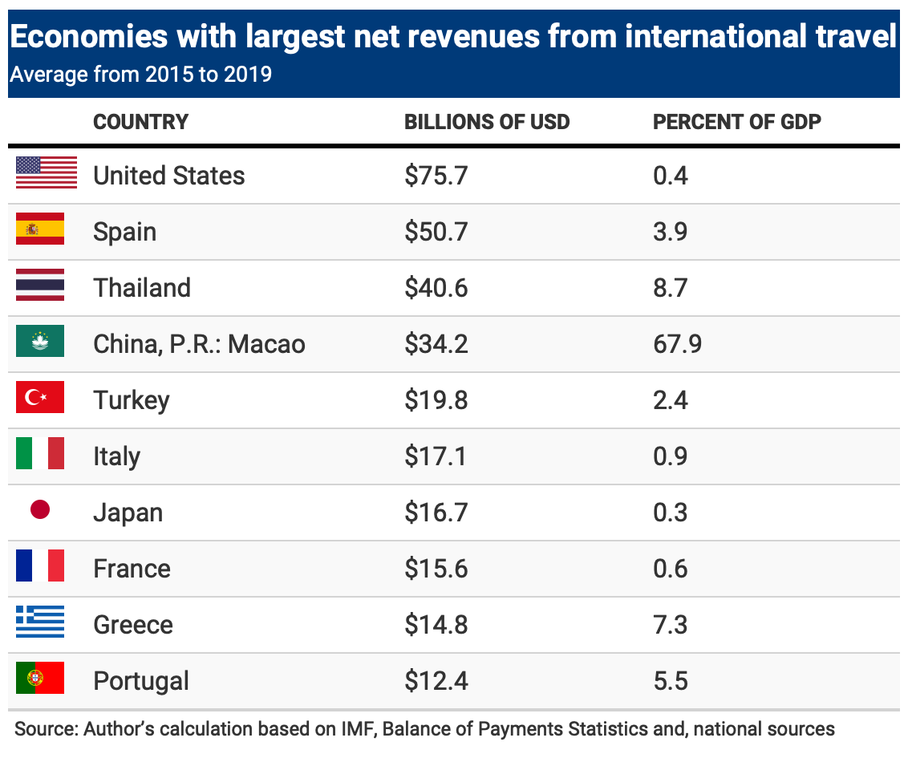

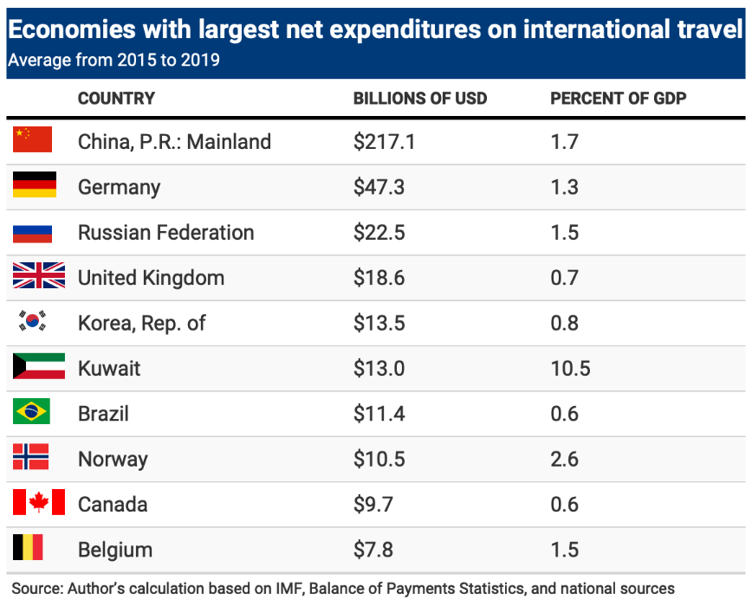

Table 3. Tourism-dependent economies: current account structure

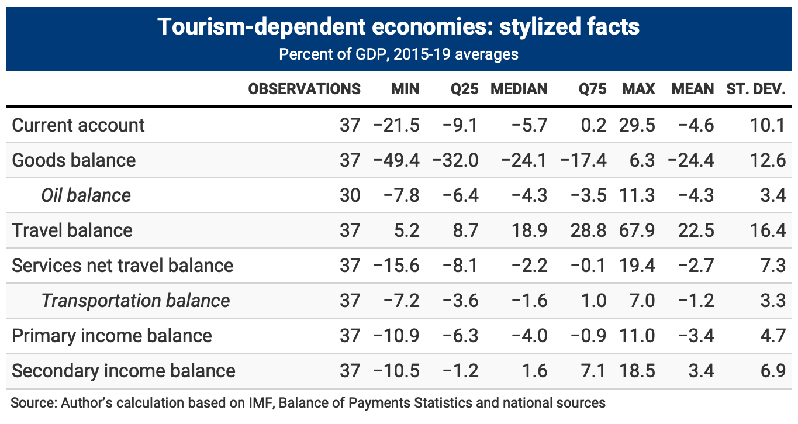

Table 4. Tourism-dependent economies and other economies: GDP per capita and external position

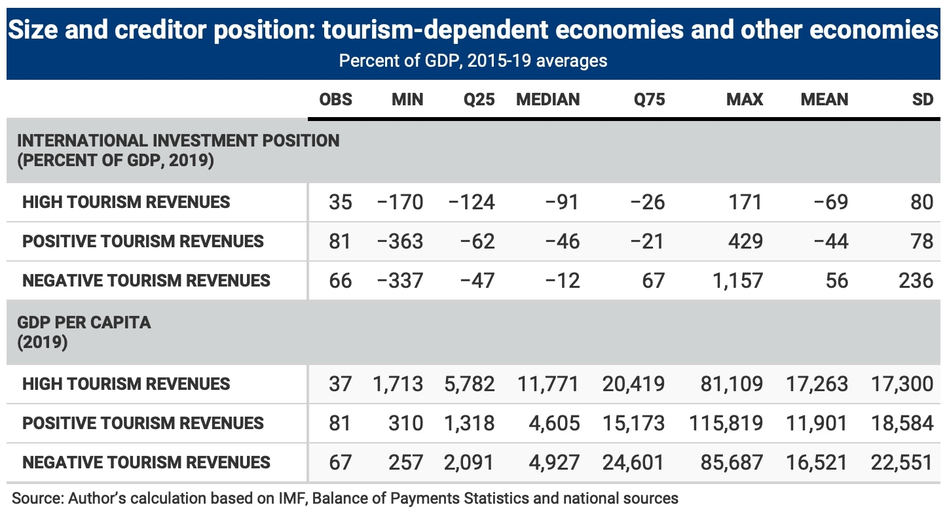

Note: High tourism revenues: average net revenues from international travel in 2015-19 > 5 percent of GDP;

Positive tourism revenues: average net revenues from international travel in 2015-19 between 0 and 5 percent of GDP.

Table 5. Economies with large net transport revenues as a share of GDP

Source: author’s calculation based on IMF, Balance of Payments Statistics and national sources.

Table 6. Current account adjustment, 2020 vs 2015-19

|  |  |  |  |  |  |  |  |
| --- | --- | --- | --- | --- | --- | --- | --- |
|  | |  |  |  |  |  |  |
|  | (1) | | (2) | (3) | (4) | (5) | (6) |
|  | All | | All ex KWT | Adv Ec | EM ex KWT | BTV>0 | BTV<0 |
|  |  | |  |  |  |  |  |
| Current account balance | -0.254 | | -0.282 | -0.134 | -0.290 | -0.329 | -0.175** |
| (pct of GDP, 2015-19) | (-1.32) | | (-1.52) | (-1.29) | (-1.15) | (-1.16) | (-2.06) |
|  |  | |  |  |  |  |  |
| Oil balance | -0.152 | | -0.278*** | -0.629*** | -0.275*** | -0.364*** | -0.237*** |
| (pct of GDP, 2015-19) | (-1.32) | | (-6.39) | (-6.04) | (-5.77) | (-5.32) | (-5.20) |
|  |  | |  |  |  |  |  |
| Net rev. from int. travel | -0.427*** | | -0.432*** | -0.798*** | -0.435*** | -0.465*** | -0.303 |
| (pct of GDP, 2015-19) | (-4.61) | | (-4.82) | (-3.17) | (-4.52) | (-3.93) | (-0.84) |
|  |  | |  |  |  |  |  |
| Constant | 1.925*** | | 1.623*** | 0.608 | 1.844*** | 1.606*** | 1.361* |
|  | (3.90) | | (3.95) | (0.99) | (3.24) | (3.12) | (1.85) |
|  |  | |  |  |  |  |  |
| Observations | 130 | | 129 | 36 | 93 | 87 | 42 |
| R2 | 0.32 | | 0.42 | 0.36 | 0.44 | 0.43 | 0.42 |
|  | |  |  |  |  |  |  |

Note: dependent variable is the difference between the current account balance in 2020 and its October 2019 WEO forecast, both scaled by GDP. t statistics in parentheses, robust standard errors. * p<0.10, ** p<0.05, *** p<0.01.

Table 7. Tourism and growth surprises: stylized facts

1. Share of tourism in GDP (average, 2015-19)

|  |  |  |  |  |  |  |  |  |  |
| --- | --- | --- | --- | --- | --- | --- | --- | --- | --- |
|  |  | Obs. | Min | 25th perc. | Median | 75th perc. | Max | Mean | Std. dev. |
|  |  |  |  |  |  |  |  |  |  |
| Direct share | All countries | 164 | 0.6 | 2.4 | 3.6 | 5.8 | 38.8 | 5.1 | 5.1 |
| Direct share | Adv. Ec. | 35 | 1.6 | 2.2 | 3.3 | 5.3 | 13.8 | 3.9 | 2.5 |
| Direct share | Emg. and Dev. Ec. | 129 | 0.6 | 2.6 | 3.6 | 6.1 | 38.8 | 5.4 | 5.5 |
|  |  |  |  |  |  |  |  |  |  |
| Total share | All countries | 164 | 1.8 | 6.6 | 9.6 | 15.7 | 87.5 | 13.9 | 13.0 |
| Total share | Adv. Ec. | 35 | 4.4 | 6.5 | 9.3 | 14.8 | 33.8 | 11.4 | 6.6 |
| Total share | Emg. and Dev. Ec. | 129 | 1.8 | 6.6 | 9.7 | 16.1 | 87.5 | 14.6 | 14.2 |

Source: Author’s calculations based on data from the World Travel and Tourism Council.

1. Growth Surprise in 2020

|  |  |  |  |  |  |  |  |  |
| --- | --- | --- | --- | --- | --- | --- | --- | --- |
|  | Obs. | Min | 25th perc. | Median | 75th perc. | Max | Mean | Std. dev. |
|  |  |  |  |  |  |  |  |  |
| All countries | 184 | -38.3 | -10.3 | -7.0 | -4.7 | 1.1 | -8.1 | 5.3 |
| Adv. Ec. | 35 | -12.4 | -8.2 | -6.1 | -4.4 | 1.1 | -6.4 | 3.0 |
| Emg. and Dev. Ec. | 149 | -38.3 | -10.7 | -7.2 | -4.9 | 0.0 | -8.5 | 5.6 |
|  |  |  |  |  |  |  |  |  |
| **High tourism** |  |  |  |  |  |  |  |  |
| All countries | 39 | -38.3 | -16.7 | -11.2 | -9.2 | -2.8 | -13.5 | 7.0 |
| Adv. Ec. | 6 | -12.1 | -10.6 | -9.2 | -8.3 | -8.0 | -9.6 | 1.7 |
| Emg. and Dev. Ec. | 30 | -38.3 | -17.7 | -12.3 | -9.5 | -2.8 | -14.0 | 7.3 |
|  |  |  |  |  |  |  |  |  |
| **Other countries** |  |  |  |  |  |  |  |  |
| All countries | 125 | -23.4 | -8.2 | -6.3 | -4.6 | 0.0 | -6.7 | 3.5 |
| Adv. Ec. | 30 | -12.4 | -7.6 | -5.8 | -4.3 | -0.1 | -6.1 | 2.5 |
| Emg. and Dev. Ec. | 95 | -23.4 | -8.4 | -6.5 | -4.7 | 0.0 | -6.9 | 3.8 |

Note: High tourism countries are those with an average direct share of tourism in GDP during 2015-19 above 6 percent (roughly the 75th percentile). For a few countries data on the tourism share in GDP is not available: hence the observations in “high tourism” and “other countries” are fewer than those for all countries. The sample excludes a few stressed economies (Iran, Lebanon, Libya, Sudan, Yemen), Guyana, as well as Macao. The latter (which is an advanced economy according to the IMF classification) has a direct tourism share of 28 percent, a total one of 59 percent, and a growth “surprise” of -55 percent.

Source: Author’s calculation based on IMF (2020), (2021) and national sources.

Table 8. Growth regressions (I)

|  |  |  |  |  |
| --- | --- | --- | --- | --- |
|  | (1) | (2) | (3) | (4) |
|  | All | All | All | All |
|  |  |  |  |  |
| COVID cases in 2020 (per 1000 popul.) | -0.014 | 0.02 | 0.025 | 0.029 |
|  | (0.37) | (1.06) | (1.06) | (1.14) |
|  |  |  |  |  |
| COVID deaths in 2020 (per 1000 popul.) | -1.09 | -2.54*** | -3.10*** | -3.11*** |
|  | (-0.82) | (-3.49) | (-3.84) | (-3.49) |
|  |  |  |  |  |
| Oxford stringency index (average 2020) | -0.08** | -0.10*** | -0.12*** | -0.11*** |
|  | (-2.49) | (-4.42) | (-5.02) | (-4.33) |
|  |  |  |  |  |
| Tourism activity (total share of GDP) |  | -0.26*** | -0.23*** | -0.21*** |
|  |  | (-12.78) | (-8.85) | (-5.85) |
|  |  |  |  |  |
| log GDP per capita |  |  | 0.22 | 0.70** |
|  |  |  | (1.05) | (2.03) |
|  |  |  |  |  |
| log population |  |  | 0.45** | 0.33 |
|  |  |  | (2.07) | (1.45) |
|  |  |  |  |  |
| VA share of agriculture (2014-19) |  |  |  | 0.11* |
|  |  |  |  | (1.95) |
|  |  |  |  |  |
| VA share of manufacturing (avg 2014-19) |  |  |  | 0.10** |
|  |  |  |  | (2.12) |
|  |  |  |  |  |
| Constant | -3.38** | 1.28 | -0.99 | -8.30** |
|  | (2.12) | (1.09) | (0.55) | (2.10) |
|  |  |  |  |  |
| Observations | 165 | 152 | 152 | 147 |
| R2 | 0.08 | 0.52 | 0.54 | 0.50 |

Note: Dependent variable is GDP growth in 2020 minus the pre-COVID growth forecast (from WEO, 2020).

t statistics in parentheses, robust standard errors. * p<0.10, ** p<0.05, *** p<0.01.

Table 9. Growth Regressions (II)

|  |  |  |  |  |  |  |  |
| --- | --- | --- | --- | --- | --- | --- | --- |
|  | (1) | (2) | (3) | (4) | (5) | (6) | (7) |
|  | All | AE | EM | All | Dir. Tour<10 | Dir. Tour<5 | All |
| COVID cases in 2020 | 0.029 | 0.0006 | 0.04 | 0.03 | 0.03 | 0.04* | 0.05** |
| (per 1000 popul.) | (1.14) | (0.02) | (1.11) | (1.21) | (1.19) | (1.88) | (1.99) |
|  |  |  |  |  |  |  |  |
| COVID deaths in 2020 | -3.11*** | -2.50** | -2.99** | -3.02*** | -3.12*** | -3.26*** | -3.31*** |
| (per 1000 popul.) | (3.49) | (2.51) | (2.53) | (3.51) | (3.56) | (3.31) | (3.50) |
|  |  |  |  |  |  |  |  |
| Oxford stringency index | -0.11*** | 0.01 | -0.11*** | -0.11*** | -0.12*** | -0.12*** | -0.09*** |
| (average 2020) | (4.33) | (0.28) | (3.89) | (4.38) | (4.35) | (5.24) | (3.43) |
|  |  |  |  |  |  |  |  |
| Tourism activity | -0.21*** | -0.28*** | -0.19*** |  |  |  |  |
| (total share of GDP) | (5.85) | (6.46) | (4.67) |  |  |  |  |
|  |  |  |  |  |  |  |  |
| log GDP per capita | 0.70** | 2.70*** | -0.10 | 0.59* | 0.53 | 0.57* | 0.76** |
|  | (2.03) | (5.12) | (-0.21) | (1.75) | (1.59) | (1.71) | (2.33) |
|  |  |  |  |  |  |  |  |
| log population | 0.33 | -0.44* | 0.40 | 0.39* | 0.34 | 0.52** | 0.34* |
|  | (1.45) | (-1.75) | (1.45) | (1.75) | (1.50) | (2.14) | (1.70) |
|  |  |  |  |  |  |  |  |
| VA share of agriculture (2014-19) | 0.11* | 0.52* | 0.07 | 0.11* | 0.10* | 0.09* | 0.16*** |
|  | (1.95) | (1.82) | (1.29) | (1.94) | (1.86) | (1.94) | (2.80) |
|  |  |  |  |  |  |  |  |
| VA share of manufacturing | 0.10** | 0.10** | 0.13** | 0.11** | 0.12** | 0.13*** | 0.15*** |
| (avg 2014-19) | (2.12) | (2.17) | (2.20) | (2.36) | (2.42) | (2.63) | (3.18) |
|  |  |  |  |  |  |  |  |
| Tourism activity |  |  |  | -0.51*** | -0.45*** | -0.18 |  |
| (direct share of GDP) | |  |  | (6.25) | (2.73) | (0.75) |  |
|  | |  |  |  |  |  |  |
| Net revenues from int. travel | |  |  |  |  |  | -0.23*** |
| pct of GDP, 2015-19 |  |  |  |  |  |  | (3.77) |
|  |  |  |  |  |  |  |  |
| Constant | -8.30** | -32.5*** | -2.42 | -7.69* | -7.1* | -8.9** | -13.1*** |
|  | (2.10) | (4.80) | (0.56) | (1.91) | (1.82) | (2.43) | (3.31) |
|  |  |  |  |  |  |  |  |
| Observations | 147 | 35 | 112 | 147 | 136 | 108 | 155 |
| R2 | 0.50 | 0.79 | 0.50 | 0.50 | 0.36 | 0.38 | 0.44 |

Note: Dependent variable is GDP growth in 2020 minus the pre-COVID growth forecast (from WEO, 2020).

t statistics in parentheses, robust standard errors. * p<0.10, ** p<0.05, *** p<0.01.

1. The only net creditor countries among those with net international travel revenues above 5 percent of GDP are financial centers (Bahrain, Macau, Malta, Mauritius) and Iceland.
2. The “other” category includes services that are auxiliary to transport such as cargo handling charges, storing and warehousing etc. See IMF (2013).
3. Kuwait’s reported current account surplus increased in 2020 despite a massive worsening of the oil balance, because of a $10 billion upward jump in reported investment income.
4. We exclude from the sample a few economies affected by economic stress and political strife, as discussed at the beginning of the next sub-section.
5. We use the IMF definition of advanced economies: a full set of countries is included in the Appendix.
6. The index is constructed from nine indicators including school closures, workplace closures, and travel bans.
7. The drop in the overall explanatory power of the regression is due to a sample composition effect—the sectoral composition of output is not available for a few island economies that contribute to the fit of the overall regression. Using the same sample for the regressions in columns (3) and (4) reduces the fit of the column (3) specification to 0.45, without altering the statistical and economic significance of the coefficients.